**Manufacturing cost reduction - Manufacturing Sector**

GOKULNATH K & E24755

**Overview**

Manufacturing cost reduction focuses on lowering production expenses while maintaining efficiency and quality. A data analyst examines data on materials, labor, and processes to find cost-saving opportunities. This involves identifying inefficiencies, optimizing resource use, and reducing waste. Data-driven insights help guide decisions that lead to improved profitability in the manufacturing sector.

**Objective**

1. Optimize Resource Allocation: Ensure efficient use of materials, labor, and energy by analyzing consumption patterns and identifying areas for cost-saving improvements.
2. Reduce Waste: Use data to pinpoint areas of excessive waste in production processes and implement lean manufacturing principles.
3. Improve Production Efficiency: Analyze machine downtime, cycle times, and bottlenecks to streamline workflows and reduce delays.
4. Monitor and Lower Material Costs: Track raw material costs and inventory levels to identify opportunities for bulk purchasing, supplier negotiation, or material substitution.
5. Enhance Labor Productivity: Use data to assess workforce performance, optimize shifts, and implement automation where applicable to reduce labor costs.
6. Energy Usage Optimization: Analyze energy consumption data to identify inefficient equipment or processes and propose energy-saving initiatives.
7. Reduce Overhead Costs: Analyze non-production-related expenses, such as maintenance and logistics, to find ways to lower operational overhead.
8. Improve Quality Control: Reduce costs from defects or rework by identifying trends in quality data and implementing preventive measures.

**Assigned Task(s)**

* Manufacturing cost reduction - Manufacturing Sector.
* **Status:** Completed.
* **Details:**

1. Data Loading: Imports necessary libraries and loads a manufacturing cost reduction dataset.
2. A line plot visualizes the trend of total manufacturing costs over time, helping to identify fluctuations and overall trends.
3. A bar plot displays the average costs of materials, labor, energy, and maintenance, providing insights into the major cost contributors.
4. A heatmap reveals the relationships between various variables, including production volume, costs, and defects, aiding in identifying key correlations.
5. Scatter Plots:
6. Total Cost vs Production Volume: Illustrates how total costs vary with production volume for different products.
7. Defects vs. Production Volume: Shows the relationship between production volume and the number of defects, highlighting quality issues.
8. Labor Cost vs. Machine Hours: Analyzes how labor costs relate to machine usage.
9. Monthly Cost Trend Analysis: A line plot tracks the total cost trend on a monthly basis, allowing for seasonal analysis of manufacturing expenses.
10. Defects Distribution Histogram: A histogram displays the frequency distribution of defects in manufacturing, helping to understand the spread and identify common defect levels.

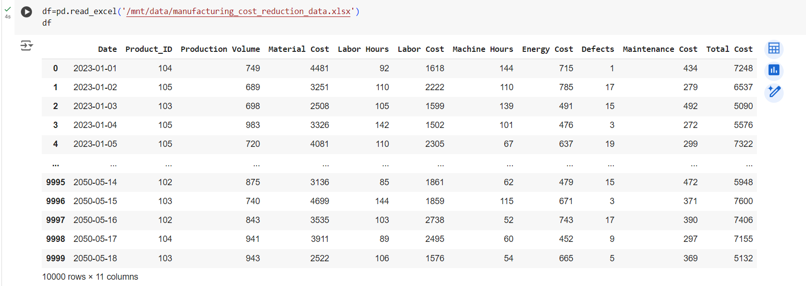

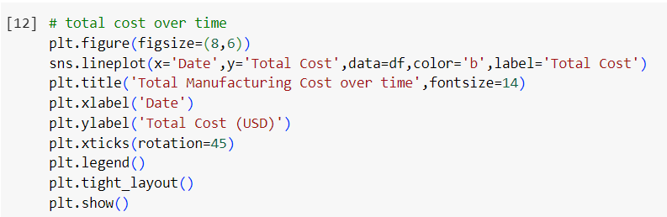

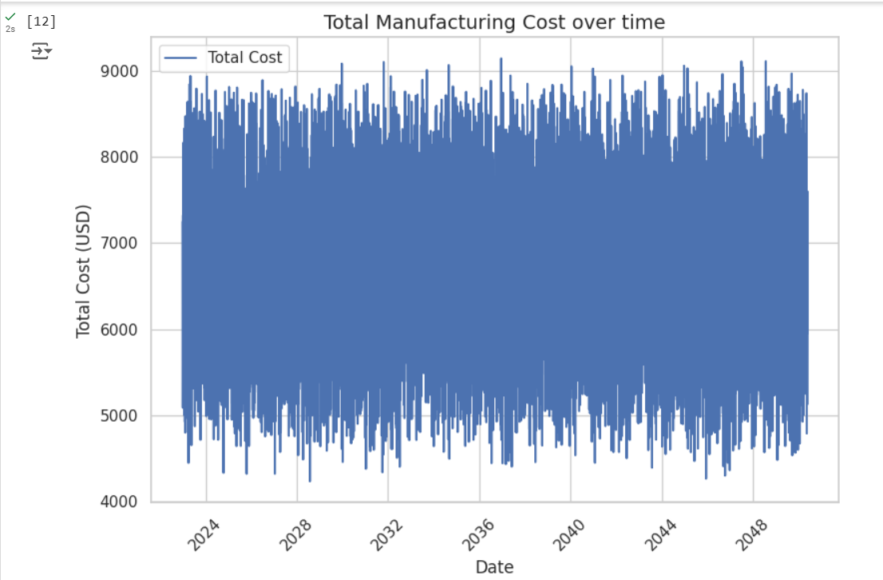

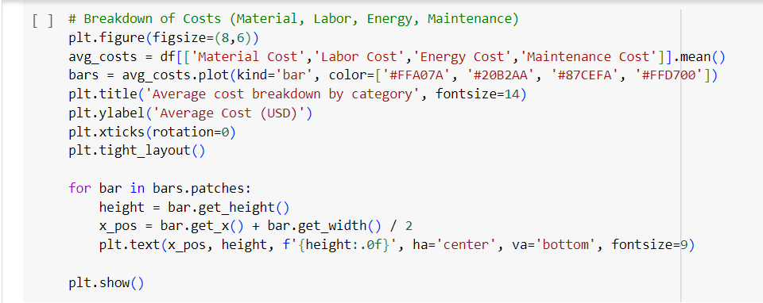

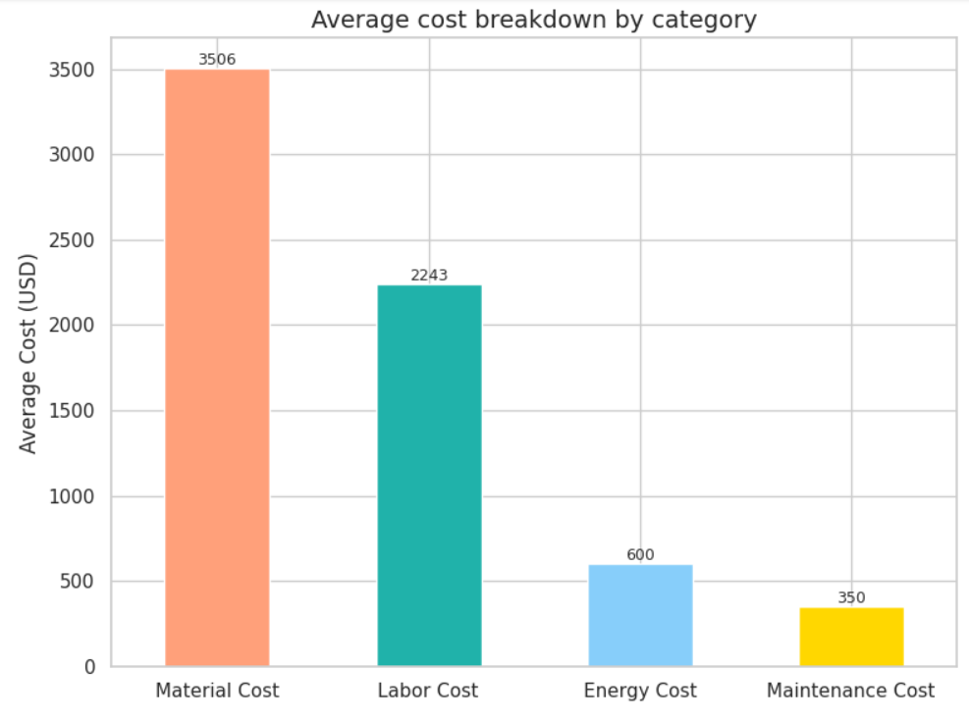

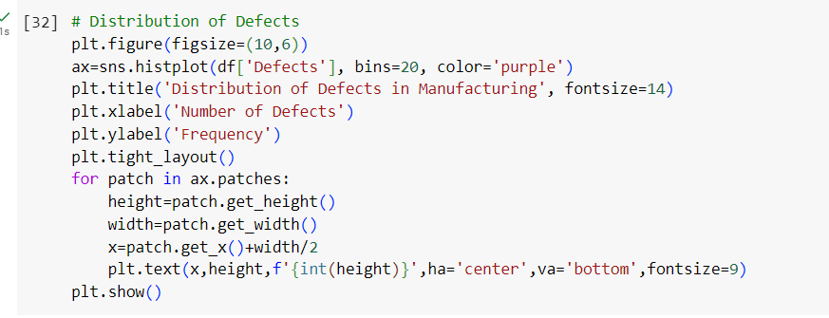

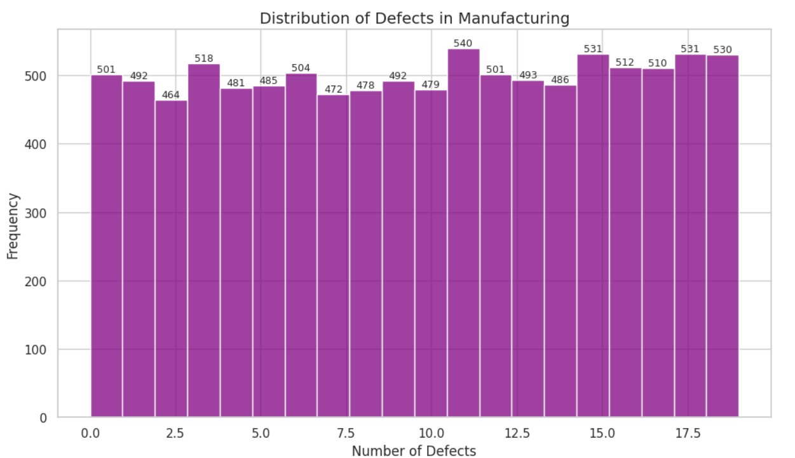

**Progress**

* **Accomplishments:**

1. Analyzed manufacturing costs over time, identifying key trends and fluctuations to inform budgetary decisions.
2. Developed visualizations to break down costs by category, highlighting major contributors and opportunities for cost savings.
3. Utilized correlation analysis to uncover relationships between production metrics and defects, leading to targeted quality improvement initiatives.

* **Metrics:**

1. Total Cost Over Time: Identify significant fluctuations (≥5%) in total manufacturing costs over the specified period.
2. Average Cost Breakdown by Category: Determine cost contributors with the largest segment being less than 40% of total costs.
3. Correlation Heatmap: Prioritize areas for cost reduction based on strong correlations (≥0.5 or ≤-0.5) among key variables.
4. Total Cost vs. Production Volume: Aim for a 5% cost reduction per additional unit produced as production volume increases.
5. Defects vs. Production Volume: Target a defect rate below 2% in high-volume products for quality control effectiveness.
6. Labor Cost vs. Machine Hours: Seek a 10% reduction in labor costs per machine hour to improve operational efficiency.
7. Monthly Total Cost Trend: Investigate months with cost increases exceeding 5% for corrective actions.
8. Distribution of Defects: Focus on the top 20% of defect categories contributing to overall defects for targeted improvements.

**Challenges and Solutions**

* **Challenges Faced:**

1. Inaccurate or incomplete data can lead to unreliable insights.
2. Difficulty in combining data from various systems complicates analysis and obscures a comprehensive view of costs.

* **Solutions Implemented:**

1. Implement robust processes to ensure data accuracy and completeness before analysis.
2. Use integrated analytics platforms that can seamlessly combine data from multiple sources for a holistic view.

**Next Steps**

* **Upcoming Tasks:** Prepare by analyzing relevant datasets, utilizing visualization tools for clear insights, and engaging stakeholders to ensure effective implementation of data-driven strategies.
* **Goals:** Establish actionable plans, utilize advanced analytics for performance tracking, and continuously adapt strategies based on real-time data to meet manufacturing goals effectively.

**Conclusion**

* **Summary:** Manufacturing cost reduction is vital for enhancing operational efficiency and competitiveness. By leveraging data analytics, companies can identify cost drivers and implement targeted strategies to minimize waste and optimize resources. Continuous monitoring and adaptation to market changes are essential for sustaining improvements and achieving long-term success.
* **Acknowledgements:** Thank you all for your attention and engagement, I appreciate your interest in the Manufacturing cost reduction - Manufacturing Sector.